Docker Commands

Docker Run command
$ docker run <image_name>
$ docker run --name <container_name> <image_name>

Docker Pull
$ docker container create <imagename> # pull + create container
$ docker container start <containerid> # starts the container
$ docker run < imagename> # pull + create container + start the container.

Docker PS
$ docker ps [options..]
- -a flag: shows us all the containers, stopped or running.
- -l flag: shows us the latest container.
- -q flag: shows only the Id of the containers.

Docker Stop
$ docker stop <container_ID>

Docker Start
$ docker start <container_ID>

Docker rm
$ docker rm {options} <container_name or ID>
- -f flag: remove the container forcefully.
- -v flag: remove the volumes.
- -l flag: remove the specific link mentioned

Docker RMI.
docker rmi <image ID/ image name>
docker rmi <repository>:<tag> # Removes the tags for that particular image

Docker Images
$ docker images

Docker exec
This command allows us to run new commands in a running container. This command only works until the container is running, after the container restarts, this command does not restart.
- d flag: for running the commands in the background.
- -i flag: it will keep STDIN open even when not attached.
- -e flag: sets the environment variables
$ docker exec {options}
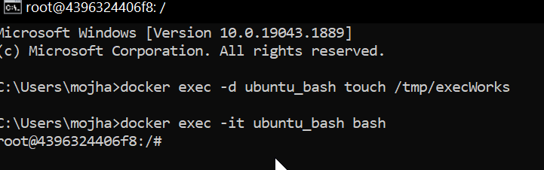

Docker Ports (Port Mapping)
In order to access the docker container from the outside world, we have to map the port on our host( Our laptop for example), to the port on the container. This is where port mapping comes into play.

$ docker run -d -p <port_on_host> <port_on_container> Container_name

Docker Login
The Docker login command will help you to authenticate with the Docker hub by which you can push and pull your images.
docker login

Docker Push
Once you build your own customized image by using Dockerfile you need to store the image in the remote registry which is DockerHub for that you need to push your image by using the following command.

docker push <Image name/Image ID>
Docker Build
docker build -t image_name:tag .

Docker Stop
docker stop container_name_or_id

Stop Multiple Containers
docker stop container1 container2 container3

Docker Restart
While running the containers in Docker you may face some errors and containers fails to start. You can restart the containers to resolve the containers by using the following commands.
docker restart container_name_or_id

Docker Inspection
Docker containers will run into some errors in real time to debug the container's errors you can use the following commands.
docker inspect container_name_or_id

Docker Commit command
After running the containers by using the current image you can make the updates to the containers by interacting with the containers from that containers you can create an image by using the following commands.
docker commit container_name_or_id new_image_name:tag

